Cystic Fibrosis

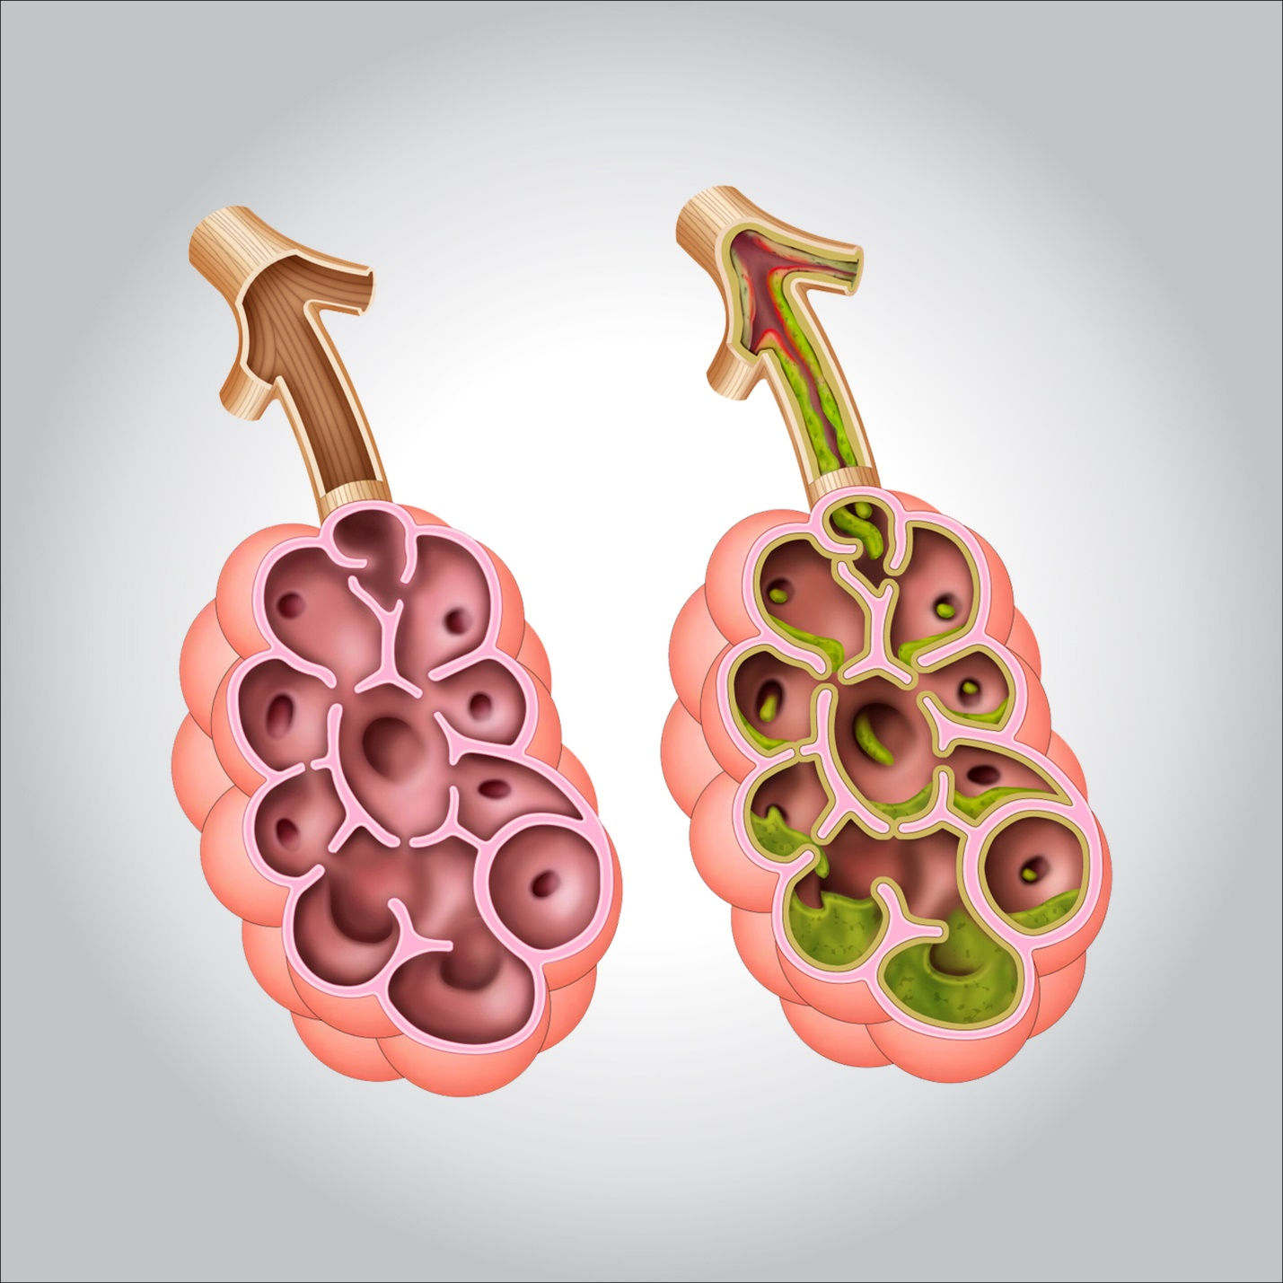

**Cystic fibrosis is a genetic disease that causes the body to produce thick, sticky mucus that clogs the lungs, leads to infection, and blocks the pancreas, which stops digestive enzymes from reaching the intestine where they are required in order to digest food.**

**What do we know about heredity and cystic fibrosis?**

**Mutations in a single gene – the Cystic Fibrosis Transmembrane Regulator (CFTR) gene – causes CF.**

**In normal cells, the CFTR protein acts as a channel that allows cells to release chloride and other ions. But in people with CF, this protein is defective and the cells do not release the chloride. The result is an improper salt balance in the cells and thick, sticky mucus. Researchers are focusing on ways to cure CF by correcting the defective gene, or correcting the defective protein.**

**Gene therapy offers great promise for life-saving treatment for CF patients since it targets the cause of CF rather than just treating symptoms. Gene therapy for CF had its started when scientists successfully corrected faulty CFTR genes by adding normal copies of the gene to laboratory cell cultures.**

**In 1993, the first experimental gene therapy treatment was given to a patient with CF. Researchers modified a common cold virus to act as a delivery vehicle – or “vector”- carrying the normal genes to the CFTR cells in the airways of the lung.**



**Finding the best delivery system for transporting normal CFTR genes is only one problem that scientists must solve to develop an effective treatment for CF. Scientists must also determine the life span of affected lung cells, identify the “parent cells” that produce CFTR cells, find out how long treatment should last and how often it needs to be repeated.**

**The first cystic fibrosis gene therapy experiments have involved lung cells because these cells are readily accessible and because lung damage is the most common, life-threatening problem in CF patients. But scientists hope that the technologies being developed for lung cells will be adapted to treat other organs affected by CF.**

**What are the symptoms?**

**CF has a variety of symptoms, including very salty-tasting skin, a persistent cough and excessive appetite but poor weight gain.**

**Is there a test for the cystic fibrosis gene?**

**The “sweat test” – which measures the amount of salt in sweat – is the standard diagnostic test for those with symptoms. A high salt level indicates CF.**

**The purpose of carrier testing – a laboratory test done on a sample of blood or saliva – is to see if a couple is at risk for giving birth to a child with CF. Carrier testing is not infallible. It cannot detect all of the CF gene mutations. In rare cases, a person can have a normal test result and still be a CF carrier.**

**If both parents are carriers, they may want to consult with a genetic counselor for help in deciding whether to conceive or whether to have a fetus tested for CF.**

**Prenatal testing for CF can be done around the 11th week of pregnancy using chorionic villi sampling (CVS). This involves removing a tiny piece of the placenta. Or, the fetus can be tested with amniocentesis, around the 16th week of pregnancy. In this procedure, a needle is used to take amniotic fluid surrounding the baby for testing. Since CF cannot be treated before birth, the purpose of prenatal testing is to prepare parents to care for a baby with special health needs, or to make a decision about terminating the pregnancy.**